**Project Design Phase-I**

**Problem Solution Fit**

|  |  |
| --- | --- |
| **Date** | 30 September 2022 |
| **Team ID** | PNT2022TMID49806 |
| **Project Name** | Gas leakage monitoring and alerting system for industries |

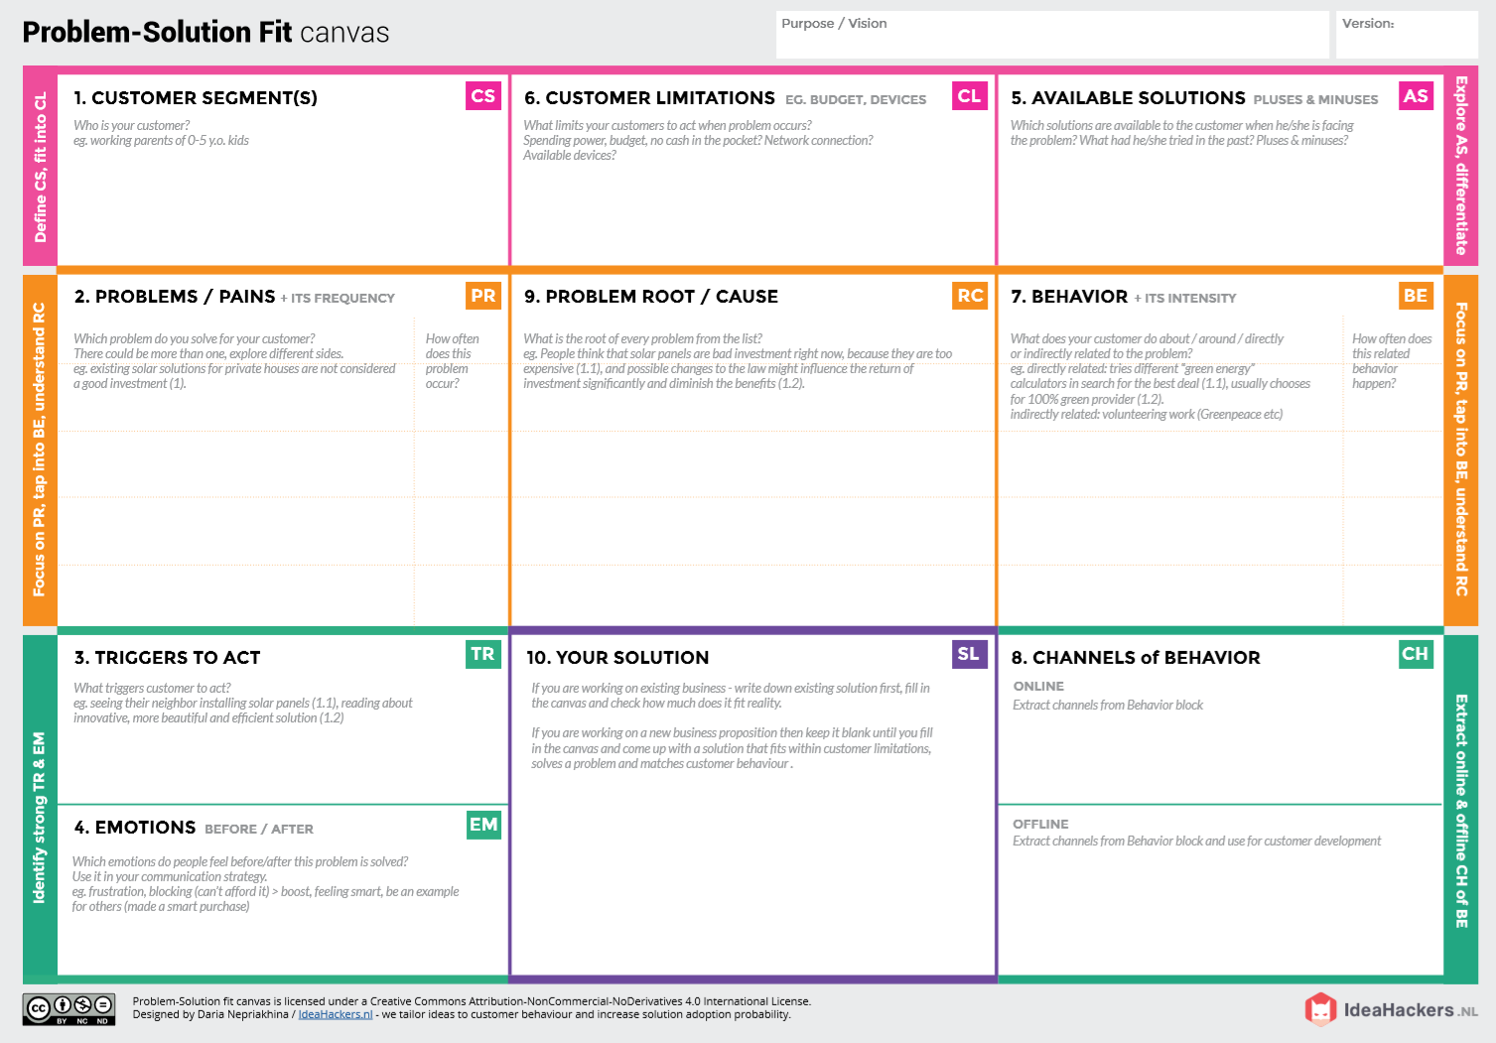

Through newspaper advertisement

Promoting through social media. With the help of social media entrepreneurs/influencer.

Develop an efficient system & an application that can monitor and alert the workers.

When the workers failed to monitor properly, the gas can cause high risk to their health or the properties of the industry.

* Using manpower as the source of monitoring the leakage causes high hazards.
* If the gas leaked is heavily toxic, there is a chance of causing hereditary health issues too.

The monitoring and controlling of the leakage could be done by the manpower. Even though man power could reduce electricity cost and monitor properly, it may cause high risk for their life. There is also a cause of some errors due to manpower.

High budget in installing other products make them to move far from modern technologies.

**Before:** The heavy losses due to the leakages made them feel of guilt due to reduced reputation of their products.

**After:** Increased the level of confidence and feel secured

The heavy damages or higher health issues due to the toxic gases urges them to find out a solution as soon as they could possible.

* Suffering from many losses due to gas leakage.
* Having no proper system for controlling or monitoring the leakage.
* Facing heavy budget problems in buying and installing a system for monitoring and controlling.

The industrialists who use gases for their manufacturing.